# *Lab 15 – Design Patterns II*

Date assigned: Monday, April 10, 2017

Date due: **Monday, April 10 14:50**

**Learning Objectives**

Upon successful completion of this lab exercise, the student will be able to:

* Describe the purpose of Design Patterns, how they are categorized and their value.
* Analyze and describe the Observer Pattern based on a Java sample.

To do:

Save this document as a Word document named **YourUserName1_YourUserName_E21_L15_DesignPatterns_II.docx** in your 420-E21 folderin your home drive. The document will hold your answers for your lab.

Submit this document to Moodle by the end of the lab.

# Design Patterns

Read about the [Design Pattern](http://www.journaldev.com/1827/java-design-patterns-example-tutorial)s. In some software development workplaces, this is the common vocabulary amongst developers. You will here them say, “Use Singleton pattern…” or “The Observer pattern should be a good solution here.”.

* 1. What is the benefit of learning design patterns? Why not re-invent the wheel or come up with a new clever solution?

Because most of the time, the patterns you’re using are one’s that have been developed for years and have been perfected and written by people who are likely smarter than you are. Industry standard and well defined, lower maintenance.

* 1. What are the three main categories for design patterns?

**Creational, structural,** and**behavioral**

* 1. Describe each category in a single sentence or two.
* Creational design patterns provide solution to instantiate a object in the best possible way for specific situations.
* Structural patterns provide different ways to create a class structure, for example using inheritance and composition to create a large object from small objects.
* Behavioral patterns provide solution for the better interaction between objects and how to provide lose coupling and flexibility to extend easily.

# Observer Pattern

Read about the [Observer Pattern](http://www.journaldev.com/1739/observer-design-pattern-in-java), which has a simple implementation of this pattern, and answer the following questions.

1. What data structure does the Subject class use to keep track of the observers? (indicate the variable name and type)

* List<Observer> observers

1. When does the Subject class add to the list of observers? (indicate the method)

public void register(Observer obj)

1. How are the Observers notified when there is an update?

public void notifyObservers()

1. Once the observer is notified, how does it get updated data? Is this a push or a pull model?

* Pull model, because the observer sends a message back

1. Draw a sequence diagram based on the main function of the ObserverPatternTest. Ensure that all public methods that are invoked as part of the sequence are shown. Insert diagram below:

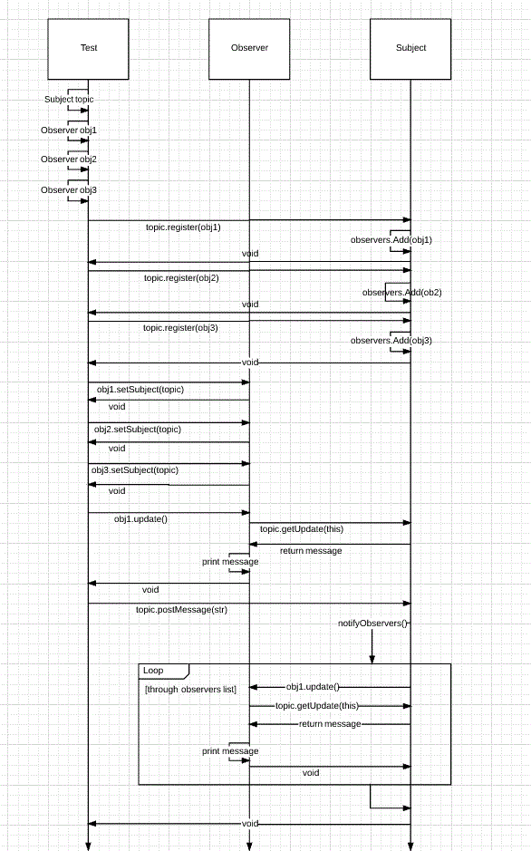

# Part C - Assessment

1. What did you learn in completing this lab?

patterns

1. What did you have difficulty with?

Sequence diagram

1. What did you do well?

Googled

1. How many hours did you spend in completing this lab?

1.5

1. What took you the most time

Sequence diagram

To Submit

When you have completed the assignment, upload the **YourUserName_E21_L15_DesignPatterns_II.docx** document to Moodle.